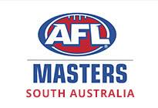

Townsville

2019

Carnival

South Australian

Information & Registration Pack

Introduction

AFL Masters SA President and Committee Welcome
Welcome to the AFL Masters SA Information & Registration pack. This has been prepared to inform you of important dates and commitments regarding the Football Carnival to be held at Townsville from 29th September to 5th October 2019.

The ovals we may be playing on are;
Riverway stadium (Main AFL oval) Riverway Drive, Townsville
Murray stadium, home of the “Curra Swans &Hermit park Tigers” Merv Crossman drive Townsville
Magnetic Island
There are important dates and information in this pack that you need to be aware of. The method of purchasing your merchandise (jumper, shorts, socks, polo, dress shirt etc.) is the same as the previous 4 years, from Viv Sports.

This year 2019, all the kit will be the same as the past 4 years consisting of Jumper, Shorts, Socks, Polo Top, and Dress Shirt. Other gear is also available but is optional. Please go to Viv Sports web site to order your gear.

The AFL Masters Carnivals are an enjoyable experience, where you will develop lifelong friendships with people from within your State and Nationally.

There’s a wide range of accommodation available, for assistance in finding accommodation, please contact Mark Good, carnival director.

It is our goal, as a committee, to make the Carnival experience as enjoyable as possible and we encourage new players and past Carnival players to get involved and make it a family experience.

We would like to thank in advance the many people who will make this another successful event; the Sponsors, Coaches, Trainers, Umpires, Team Managers, and Committee members.
Please provide all the requested information and keep in contact with your club delegate and the SA AFL Masters. Email will be the predominant form of communication.

The President

AFL Masters SA

Contact Details

All the following contacts are South Australian AFL Masters positions:

President
Brenton Wortley | president@aflmasterssa.com | 0412 822 777

Vic President
Marty Lilburne | vice.president@aflmasterssa.com | 0438 891 629

Secretary/Marketing
Steve Brooks | secretary@aflmasterssa.com | 0403 582 191

Treasurer
Bob Cannan | treasurer@aflmasterssa.com | 0402 787 668

Carnival Director (Carnival registration forms and payments)
Mark Good | Carnival.director@aflmasterssa.com.au | 0417 089 069

Carnival Head Trainers
Lance Gum | stageright@bigpond.com | 0407 127 272

Football Director
Ryan Bolton | football.director@aflmasterssa.com | 0407 724 996

Umpires Director
Glenn Watkins | umpires.director@aflmasterssa.com.au | 0420 355 938

Women’s representative
Lucy Brooke | samasterswomensfootball@gmail.com | 0424 794 066

Carnival Registration & Time Table

The Carnival will be held in Townsville this year, we are hoping to field between three and four male teams, plus possibly 2 women teams. As in the past, first to register and pay their fees will be guaranteed places in their relevant team.
To ensure an equitable process for selection of teams the following has been prepared to assist.

It is an AFL Masters SA goal to enter as many teams as possible, but we will enter the teams that best match the age group of the registered players.

The Male age groups are:
35 to 44
45 to 49
50 to 54
55 to 59
60 and over

Women teams are: 30 to 40 and an open age group 40 and over (open age group may change depending on participant numbers).

Selection for teams:
- Players who attended the previous year’s Carnival, will be given preference if they confirm their intention to attend by 31st May. Otherwise they will be considered the same as all other players. There will be 24 players maximum per team.
- Players will be placed in the appropriate team, based on their age. However, coaches may negotiate with other coaches to have a player change teams (players can only play down in grades).
- Players are considered registered for a team once the SA Carnival Director has the players Registration Form and Full Payment (Not one or the other)

The SA Carnival Director will confirm inclusion in a team & Guernsey number (e.g. via email). Clothing orders and payments direct to Viv Sports.

Viv Sports new address: - 14 Desmond Avenue, Marleston.
Ph: 1300698482
Email: admin@vivsports.com
https://vivaglobal.com.au/collections/sa-afl-masters
- All orders need to be in no later than 30th June 2019.

Players must:
- Complete a Registration Form, Player Information Form and make full payment to the SA Carnival Director (preference is via EFT)
Have the latest South Australian AFL Masters polo top, dress shirt, football Guernsey, socks and shorts. Orders for new merchandise can be placed with Viv Sports on their web site https://vivaglobal.com.au/collections/sa-afl-masters
- Arrange own transport and accommodation for the Carnival (if applicable)
- Have fun and enjoy the spirit of the AFL Masters Carnival
Please don’t look for favors if you haven’t met the Important Dates listed below, it is your responsibility

Your Guernsey & Number

If you have played in the previous year Carnival, you can use your existing number except if you are changing Grades (Divisions) and the number is already in use in the Grade you are moving to. In this instance it is your responsibility to agree to a new number with the Carnival Director.

How to Make Payments and Forms

Your payment and forms must be submitted through your club Delegate or direct to the SA Carnival Director via cash (In person) or cheque (via Mail) or Electronic Funds Transfer (EFT)

Post Cheques to:  Mark Good  1 Carramar Ave  Edwardstown 5039  Payable to: AFL Masters SA | Electronic Funds Transfer (EFT):  NAB  BSB: 085 210  Account No: 167751340  Description: Your Full Name
Important Dates
Date | Event | Comments
By 31st May 2019  Past Carnival Preference Period | Players who attended the previous year Carnival must register & pay by this date to receive any preference for inclusion in a team | After this date, previous year Carnival players are treated equally with all other players. First in with registration forms & payments have priority.
15th July 2019 | Coaches for each grade announced
By the 24th July 2019 | Registration Period | First 24 players in each age group will form the appropriate team.
Early Aug 2019 | Training Commences | Venue & dates to be advised
No later than 30th June 2019 | Order gear from Viv sports | Payment for gear direct to Viv Sports https://vivaglobal.com.au/collections/sa-afl-masters
Sun 29th Sept to Sat 5th Oct 2019 | Carnival

The Cost of the Carnival to you will be:
The Carnival is run at a break even cost to AFL Masters SA; all players are required to pay in full when they submit their registration forms.

What you get for your money | Do I need it? | Cost
Final Night Event (per person) (Fee set by National Board)  For all players, trainers, umpires etc from all States, usually over 1,200 people at the event. All Australian Teams announced for each grade, a great night to reminisce about the carnival.  Extra Adult final night ticket  Children (4 to 13 years of age) final night ticket | Compulsory  Optional  Optional | $165  $TBA  $TBA
Team Photo Registration, Insurance and Umpires (Fee set by National Board) | Compulsory | $115
SA Trainers, Equipment, Social Events  Tape etc for players, Social events (pre-Carnival BBQ, Meet and Greet and Psycho night). We provide a payment to our trainers, and a $10 contribution to the Rat Pack fund. | Compulsory | $135
Registration Total | Compulsory | $415
SA AFL Masters Gear Kit (Order and pay direct to Viv Sports see web site)  Standard Kit -:SA State Polo Top  SA State Final Night Dress Top  New State Guernsey  New State Shorts  State Socks  Casual Kit -:SA State Polo Top  New State Guernsey  New State Shorts  State Socks  Optional:  State Bag $35  Additional Guernsey $50  Additional State Shorts $26  Additional State Socks $14  Additional State Polo Top $40  Additional State Dress Shirt $40  Stubby Holder $9  Cap $10 | Compulsory (Package deal and great package prices)  Optional  Optional  Optional  Optional  Optional  Optional  Optional  Optional | $160  $120  $ +  $ +  $ +  $ +  $ +  $ +  $+  $+
Playing Gear Total | Compulsory portion only if you don’t already have it from 2014/15/16/17/18 carnivals. | $160

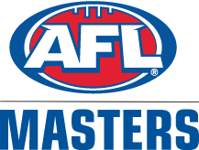

AFL MASTERS FOOTBALL CARNIVAL 2019

PLAYER REGISTRATION & SAFETY FORM
Trading as AFL MASTERS INC Reg. No A2385U ABN 52 754 583 040

State:..........SA................... Team (35-44, 45, 50, 55, 60 Women’s) :.....................................................
Surname:....................................................…… First Name .......................................................
Address:............................................................................................…… Post Code:.........…..
Telephone: (H)......................…. (Mobile).............................................................
Date of Birth:............................... Drivers Licence No.....................................................
WARNING AND DISCLAIMER
Australian rules football is dangerous! Participation can result in serious bodily injury, permanent incapacity and even death. By signing this application, you acknowledge that you have read and understood the terms upon which AFL Masters Inc may accept your application as a participant. If your application is accepted AFL Masters Inc will rely on you keeping the promises you make below.
In this document the phrase AFLM means AFL Masters Inc & Masters Australian Football Inc, its’ officers, volunteers, servants, agents and any co-contractors of Masters Australian Football.
- I have read the Rules and the Code of Conduct for the Carnival in which I am applying for participation and will at all times comply with the rules and Code of Conduct of the Carnival and any reasonable direction given to me by AFLM, my team Management and carnival umpires.
2. I will participate solely at my own risk, knowing and accepting that in participating I may become seriously injured, permanently incapacitated or killed by or as a consequence of on-field practice or competition. I acknowledge that any medical, ambulance or other associated costs are my own responsibility, even if ambulance or medical support is in attendance at the competition. I also acknowledge that it has been recommended that I take out private medical insurance cover and ambulance subscription.
- I will not engage in any conduct, on or off the field, which places other participants or AFLM at risk of injury or death and/or which is in the opinion of AFLM considered to be unreasonable or un-sportsmanlike behaviour.
4. The determination of whether my conduct places or placed other persons at risk of injury or death and/or which is or was unreasonable or un-sportsmanlike behaviour is solely at the discretion of AFLM and I agree to be bound by that determination.
6. I hereby release and indemnify AFLM and its state associations and their clubs from all claims, costs, proceedings, liabilities and expenses arising from or in any way connected with my participation in the Carnival.
7. I participate knowing that it is my responsibility to undertake a full medical examination prior to playing to ensure that I am not suffering from any illness or condition or injury that may put my health, enjoyment of life or use of my body at greater risk.

Signed Date ………………2019

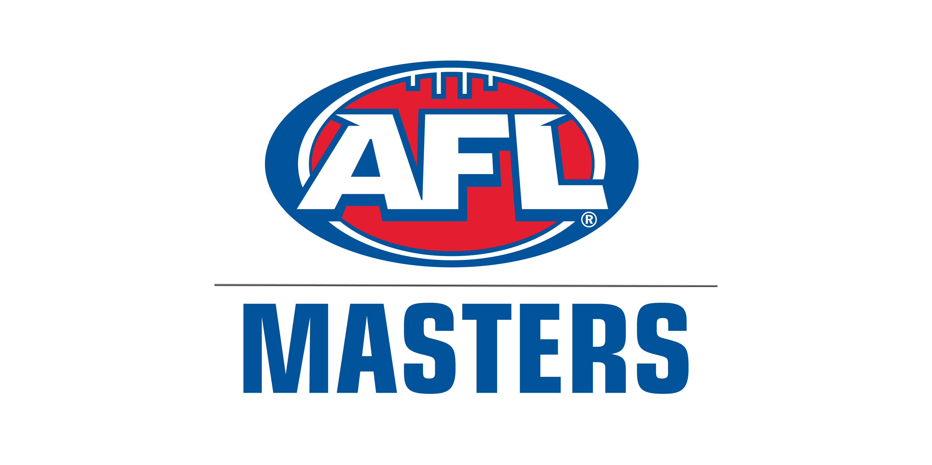
SOUTH AUSTRALIAN AFL MASTERS CARNIVAL 2019

PLAYER INFORMATION FORM

This form is to ensure that you are allocated to the correct team and AFL Masters SA have the information to co-ordinate communication with you.
This Form MUST be completed and submitted with your National Carnival Registration Form
Should a player become injured or unable to attend for other reasons, any monies paid will be refunded.

Christian Name

Surname

Nick Name
SA Club
Date of Birth
Important for Carnival Updates!!
Email Address

Mobile Phone Number

Do you have any Allergies?
Or any other conditions?
Emergency Details
Contact Person

Mobile Number

Preferred Guernsey number

Your Carnival Merchandise can be purchased by contacting Viv Sports
https://vivaglobal.com.au/collections/sa-afl-masters

Date …………………………… Return Form to Carnival Director

