Program – Mini Carnival

17th September 2017

Overview
Welcome to the 2nd and last AFL Masters SA mini carnival for 2017. The association hopes you enjoy the day and get the chance to catch up with all those players both at your club and other clubs who you have participated with over the 2017 season.
The aim of the Mini Carnivals is to build stronger relationships across the SA association both between clubs and players.
The day is also a family focussed day so please enjoy yourself, bring the family and have a great day. Additionally, be mindful as there are families at these events respectful behaviour is mandatory both on and off the field.
We are also pleased to announce the AFL Masters SA Women’s team will play at this event in readiness for their inaugural trip to the AFL Masters National Carnival.
If you have any questions or concerns prior to or on the day, please see your club delegate.
As with a normal round please ensure you arrive approx. 1 hour prior to your game to ensure you are marked off the roll and have time to prepare.

Hosts
Woodville South Football Club is the host for the 2nd Mini Carnival for 2017
Woodville South AFL Masters Facebook

Location/Facilities
Woodville South Football Club (Woodville South Sports and Community Club)
108 Ledger Rd, Woodville South SA 5011
Parking is limited however there is parking on the street.
Food and Drink facilities will be provided by the Woodville South FC

Map
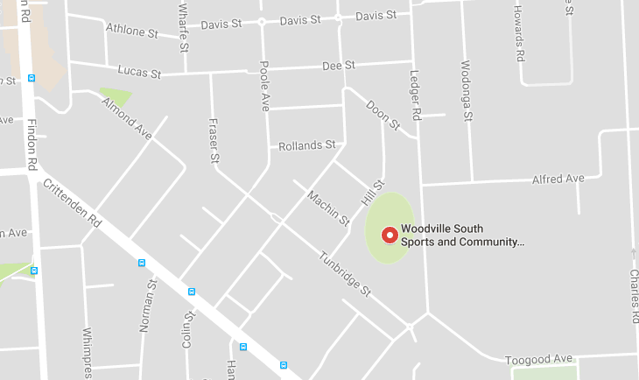

On Arrival
Players on arrival MUST report to the registration station and ensure they are marked on the roll for their respective team.
Players whose clubs have not prepaid for them will be required to pay at the time of registration.
Players not on the roll (late comers) can still participate once they have paid their registration ($10) and assigned to a team sheet.

Team Lists
Players have been pre-assigned a team within their respective age groups. State players have been assigned into teams together however due to the need to ‘balance’ numbers the Over 50’s state players have been split.
Team lists won’t be changed on request however to ensure numbers balance Team Manager and Coaches may make adjustments on the day.

Change Rooms
Change rooms and space inside is limited so players are reminded to not leave bags in rooms during matches. Once you are changed and about to play please place your bag outside the changeroom. If it’s wet there should be a space under cover.

Coaches/Managers
Please see the coaches/managers list below:
Players must report to their respective Coach/Manager
Managers will be responsible for the allocation and collection of Guernsey’s
Age Group | Team | Coach | Manager | Guernsey
35-43 | 1 | Mark Coachgood (Goody) | TBA | Blackwood
35-43 | 2 | Woodville Sth  TBA |  | Rosewater
43-49 | 1 | Damien White (Whitey) | Brad King (Diesel) | State
43-49 | 2 | TBA |  | Pooraka
Over 50 | 1 | Kim Pearce  (Pearcy) | Neil Laxton | State
Over 50 | 2 | TBA |  | Hills
Women's | 1 | Colin Thompson | TBA | N/A
Women's | 2 |  |  | N/A

Note: Players in Team 1 for the 43-49 and Over 50’s MUST bring their state playing gear

Schedule
Please see the schedule below for game times. Quarter and Half time breaks will be kept to a minimum to ensure the day stays on schedule.
Game | Start Time | Format | H/Q | Time | Finish Time
Women’s | 11am | 9-10 a Side | Halves | 15 min's | 11.40am
Over 50 | 11.50am | 16-18 a Side | Quarters | 12 min's | 12.50pm
43-49 | 1pm | 16-18 a Side | Quarters | 12 min's | 2pm
35-43 | 2.10pm | 16-18 a Side | Quarters | 12 min's | 3.10pm
Presentations/Raffle Draw | 3.30pm

General Information

Guernsey’s
Players will be provided with a guernsey for their game by the team Manager. It is critical that you return the guernsey to your team Manager after your game. Lost guernsey’s will be charged back to the individual players.

Umpires
Glen Watkins will be the Umpire coordinator for the day. He will manage the allocation of umpire to each game. Normal AFL Masters SA rules apply during the mini carnival games.

Raffle Tickets
Woodville South FC will run a raffle for the day with some great prizes so please support the club and buy a few tickets. Tickets will be available at multiple locations at the venue.
Tickets will be $2 each or 3 for $5
Prizes:
- $200 Jacket – donated by New Holland
- 2 x Meat Trays – donated by Woodville South FC
- Red & White wine (6 bottles) – donated by Lake Breeze Wines
- Andrew McCleod clothing (several pieces) – donated by Viv Sports

For further info please like AFL Masters SA on Facebook

